Name | Singh Suryansh Alok Kumar
UID no. | 2022300119
Experiment No. | Week 7

AIM: | Problem Solving Using Object Oriented Programming
Program 1
PROBLEM STATEMENT : | Mammal class that has following attributes  a) Category //animal or bird  b) No. of legs  Dog class inherits from mammal class and attributes are  a) Name  b) Age  Method calculateLifeExpectancy returns the years of the dog based on the breed.  Method popularBreed will return the most popular breed  Labrador class inherits from Dog and has attributes  a) Colour  b) Weight  Method speak returns the sound of the dog  public String speak() { return "WOOF"; }  Method calculateAvgWeight returns the average weight of all Labrador.  German Shepherd class inherits from Dog and has attributes  a) Height  b) Lifespan  Also has method that returns the sound of the dog  public String speak() { return "GRUNT"; }  Method calculateAvgHeight returns the average height of all German Shepherd.
PROGRAM: | // IMPORTING REQUIRED JAVA CLASSES  import java.util.Scanner;  // MAIN CLASS  public class Animal {  public static void main(String[] args) {  Scanner sc = new Scanner(System.in);  // CREATING ARRAY OF MAX 5 INPUTS FOR EACH DOG  Labrador[] lab = new Labrador[5];  GermanShepherd[] german = new GermanShepherd[5];  // SETTING THE DEFAULT COUNT AS 0  int noOfGerman = 0, noOfLabs = 0;  // TAKING INPUT FROM THE USER  for (int i = 0; i < 5; i++) {  System.out.println("\nEnter the details of your dog.");  System.out.print("Name: ");  String name = sc.nextLine();  System.out.print("Age: ");  int age = sc.nextInt();  System.out.print("What is the breed of the dog?\n1. German Shepherd\n2. Labrador\n");  int choice = sc.nextInt();  // BUFFER CLEAR  sc.nextLine();  // SWITCH CASE FOR FURTHER DETAILS  switch (choice) {  case 1:  System.out.print("Height: ");  int height = sc.nextInt();  if (noOfGerman == 0) {  System.out.print("Lifespan: ");  int lifespan = sc.nextInt();  GermanShepherd.setLifespan(lifespan);  }  sc.nextLine();  german[noOfGerman] = new GermanShepherd("Animal", 4, name, age, height, noOfGerman);  noOfGerman++;  break;  case 2:  System.out.print("Weight: ");  int weight = sc.nextInt();  sc.nextLine();  System.out.print("Colour: ");  String colour = sc.nextLine();  lab[noOfLabs] = new Labrador("Animal", 4, name, age, colour, weight, noOfLabs);  noOfLabs++;  }  }  // DISPLAY GERMAN SHEPHERD DETAILS  for (int i = 0; i < noOfGerman; i++) {  System.out.println(german[i].toString(i));  System.out.println();  }  // DISPLAY AVERAGE HEIGHT OF GERMAN SHEPHERDS  System.out.printf("The average height of german shepherd is %.2fm", GermanShepherd.calculateAvgHeight(noOfGerman));  System.out.println("The life expectancy of german shepherd is " + Dog.lifeExpectancy(1));  System.out.println();  // DISPLAY LABRADOR DETAILS  for (int i = 0; i < noOfLabs; i++) {  System.out.println(lab[i].toString(i));  System.out.println();  }  // DISPLAY AVERAGE WEIGHT OF LABRADORS  System.out.printf("The average weight of labrador is %.2fKg\n", Labrador.calculateAvgWeight(noOfLabs));  System.out.println("The life expectancy of labrador is " + Dog.lifeExpectancy(2));  // DISPLAY MOST POPULAR BREED  System.out.println("\nThe more popular breed is " + Dog.popular(noOfGerman, noOfLabs));  }  }  //PARENT CLASS  class Mammal {  private String category;  private int noOfLegs;  //CONSTRUCTOR OF MAMMAL CLASS  public Mammal(String category, int noOfLegs) {  this.category = category;  this.noOfLegs = noOfLegs;  }  public String toString() {  return String.format("It belongs to the category %s, and it has %d legs", category, noOfLegs);  }  }  //CHILD CLASS  class Dog extends Mammal {  private String name;  private int age;  //CONSTRUCTOR OF CHILD CLASS  public Dog(String category, int noOfLegs, String name, int age) {  super(category, noOfLegs);  this.name = name;  this.age = age;  }  //RETURN LIFE EXPECTENCY BASED ON BREAD OF DOG  public static int lifeExpectancy(int i) {  return (i == 1) ? 9 : 12;  }  //RETURN THE BREED WITH A HIGHER COUNT  public static String popular(int noOfGerman, int noOfLabs) {  return (noOfGerman > noOfLabs) ? "German Shepherd" : (noOfGerman < noOfLabs) ? "Labrador" : "Both are equally popular";  }  @Override  public String toString() {  return String.format("The name of the dog is %s and its age is %d.\n%s", name, age, super.toString());  }  }  //DERIVED CLASS FROM CHILD CLASS  class GermanShepherd extends Dog {  private static int[] height = new int[5];  private static int lifespan;  //CONSTRUCTOR OF G.S CLASS  public GermanShepherd(String category, int noOfLegs, String name, int age, int heights, int noOfGerman) {  super(category, noOfLegs, name, age);  height[noOfGerman] = heights;  }  //SETTER FOR LIFESPAN  public static void setLifespan(int life) {  lifespan = life;  }  //METHORD TO SPEAK  public String speak() {  return "GRUNT";  }  //METHORD TO CALCULATE AVG HEIGHT  public static double calculateAvgHeight(int k) {  double avg = 0;  for (int i = 0; i < k; i++) {  avg += height[i];  }  avg /= k;  return avg;  }  public String toString(int i) {  return String.format("The breed of the dog is german shepherd. Its height is %dcm and lifespan is %d years. It speaks %s.\n%s", height[i], lifespan, speak(), super.toString());  }  }  class Labrador extends Dog {  private String colour;  private static int[] weight = new int[5];  //CONSTRUCTOR OF LAB CLASS  public Labrador(String category, int noOfLegs, String name, int age, String colour, int weights, int noOfLabs) {  super(category, noOfLegs, name, age);  this.colour = colour;  weight[noOfLabs] = weights;  }  //METHORD TO SPEAK  public String speak() {  return "WOOF";  }  //METHORD TO CALCULATE AVG WEIGHT  public static double calculateAvgWeight(int k) {  double avg = 0;  for (int i = 0; i < k; i++) {  avg += weight[i];  }  avg /= k;  return avg;  }  public String toString(int i) {  return String.format("The breed of the dog is labrador. It's weight is %dKg and colour is %s. It speaks %s.\n%s", weight[i], colour, speak(), super.toString());  }  }
RESULT:
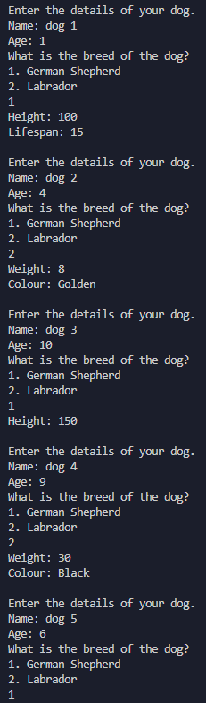
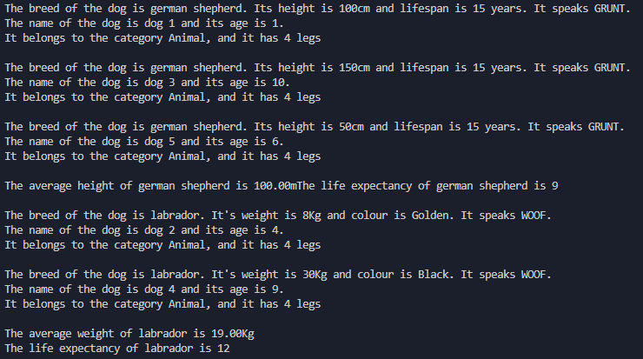
THEORY: | 1) STRING FORMAT:  In Java, the `String` class provides several methods for formatting strings. The most commonly used method is `String.format()`, which uses format specifiers to create formatted strings. Here's an example:  ```  String name = "John";  int age = 25;  double height = 5.8;  String formattedString = String.format("My name is %s, I am %d years old, and my height is %.2f feet.", name, age, height);  System.out.println(formattedString);  ```  Output:  ```  My name is John, I am 25 years old, and my height is 5.80 feet.  ```  In the example above, `%s` is a format specifier for a string, `%d` is a format specifier for an integer, and `%.2f` is a format specifier for a floating-point number with two decimal places.  You can use various format specifiers to control the formatting of different types of values. Here are some commonly used format specifiers:  - `%d` for integers  - `%f` for floating-point numbers  - `%s` for strings  - `%c` for characters  - `%b` for booleans  - `%t` for date/time values  - `%n` for a newline character  You can also specify additional formatting options such as width, precision, and alignment. For more details and advanced formatting options, you can refer to the Java documentation on formatting strings using `String.format()`.  2) TO STRING:  In Java, the `toString()` method is a built-in method provided by the `Object` class, which is the superclass for all classes in Java. By default, every class inherits this method from the `Object` class, and you can override it in your own classes to provide a meaningful string representation of the object.  Here's an example of overriding the `toString()` method in a custom class:  ```  public class Person {  private String name;  private int age;  public Person(String name, int age) {  this.name = name;  this.age = age;  }  @Override  public String toString() {  return "Person[name=" + name + ", age=" + age + "]";  }  }  public class Main {  public static void main(String[] args) {  Person person = new Person("John", 25);  System.out.println(person.toString()); // toString() method is implicitly called  // Alternatively, you can simply use:  // System.out.println(person);  }  }  ```  Output:  ```  Person[name=John, age=25]  ```  In the example above, the `Person` class overrides the `toString()` method to return a custom string representation of a `Person` object. When you call `toString()` on an instance of the `Person` class, it will return the formatted string `"Person[name=John, age=25]"`.  You can also directly use `System.out.println(object)` without explicitly calling the `toString()` method, as `println()` automatically invokes `toString()` on the given object.  By overriding the `toString()` method, you can provide a more meaningful and descriptive string representation of your objects, which can be useful for debugging, logging, or displaying information about the object.  3) SUPER:  In Java, the super keyword is used to refer to the superclass of a subclass. It can be used to access superclass members or invoke superclass constructors. It allows you to reuse superclass implementation, access superclass state, and ensure proper initialization of superclass fields in subclass constructors.  4) @OVERIDE:  In Java, the `@Override` annotation is used to indicate that a method in a subclass is intended to override a method in its superclass. It is an optional annotation that provides compile-time checking and documentation, helping to ensure that the method is correctly overriding a method in the superclass.  Here's an example:  ```  public class Animal {  public void makeSound() {  System.out.println("Animal is making a sound");  }  }  public class Dog extends Animal {  @Override  public void makeSound() {  System.out.println("Dog is barking");  }  }  public class Main {  public static void main(String[] args) {  Dog dog = new Dog();  dog.makeSound();  }  }  ```  Output:  ```  Dog is barking  ```  In the example above, the `Dog` class extends the `Animal` class and overrides the `makeSound()` method. By adding the `@Override` annotation before the `makeSound()` method in the `Dog` class, we indicate to the compiler that we intend to override a method from the superclass.  If the `@Override` annotation is used but the annotated method does not actually override a method in the superclass (e.g., due to a misspelling or incorrect method signature), the compiler will generate an error, notifying you of the mistake.  Using the `@Override` annotation is good practice as it helps catch errors at compile-time and improves code readability by clearly indicating the intention to override a method. However, it is not mandatory to use the annotation for method overriding.

